Bottle Flipping Graphing Activity
Directions: Using the collected data, create three graphs that will display your results: Partner Data, Group Data, and Class Data. Graphing programs can be found on the class Weebly. Analyze the graph and use this data to answer the following questions. Justifying your reasoning, you will present your argument to the class. Your presentation could be a poster, power-point, prezi, etc.
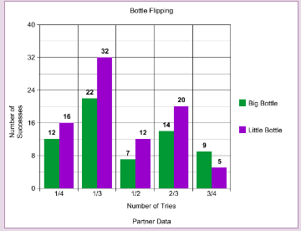
Analysis

- Was your prediction correct?
- If you were to enter the World Bottle Flipping Championship and you could fill your own bottle, how full would you fill it? Using your graphs, justify your reasoning.
- How does the amount of water impact the landing rates?
- Why did this experiment not include a full bottle? Why did not include an empty bottle?
- Does how you flip the bottle effect the outcome? Height, hand, clockwise, counterclockwise? Explain.
- Was it hard to go from one weight to the other? Explain.
- Why did some bottles bounce more than others?
- Does the landing surface alter your chances of sticking the landing?
- Why is it so hard to “cap” the bottle?
- Did you change your flipping method throughout this activity? Explain.

- Does it matter what kind of bottle you use? What would be your ideal bottle?

